PROJECT PROGRESS REPORT
PROJECT PROGRESS REPORT
(Reporting No. 07/ 10)
Reporting Period: From 27/08/2026 To 03/09/2026
1. Student Information
Student Name | MAN VISHNUBHAI PATEL
Enrollment Number | 25IC03CA053
Program/Branch | MCA / ICA
Semester | 3
Contact Number | 8849948963
Email ID | 25ic03ca053@ppsu.ac.in

2. Project Details
Type | Research Project
Department/Domain | MCA (DS/ML) /AI &ML
Mentor Name | Mr. Srikant Singh
Start Date | 08-06-2026
End Date | 03-10-2026

3. Project Title
- OpenCV - Based System for Crack Identification and Width Estimation

4. Progress During the Reporting Period
A. Previous Reporting Review
Planned Task | Status | Remarks
Install & Import Libraries | Completed | Required libraries were installed and imported successfully for image processing and crack analysis.
Project Configuration | Completed | Project configuration, output directories, and OpenCV parameters were successfully configured.
Output & Mask Directories | Completed | Directories for processed images, crack masks, and annotated images were created successfully.
OpenCV Parameters | Completed | Gaussian blur, black-hat transformation, morphological processing, and crack-area parameters were configured and tested.
Pixel-to-mm Calibration | Completed | Pixel-to-mm calibration was configured and integrated with crack-width estimation.
Image Upload | Completed | Image upload functionality was implemented and tested for crack-image analysis.
Image Preprocessing | Completed | Image preprocessing was implemented to improve image quality and prepare images for analysis.
Crack Segmentation | Completed | Crack regions were successfully segmented using image-processing and morphological techniques.
Crack Detection | Completed | Crack detection was implemented and tested on input images.
Crack Width Estimation | Completed | Crack-width estimation was implemented using detected crack regions and calibration settings.
Risk Classification | Completed | Risk classification was implemented based on the measured crack characteristics and defined thresholds.
Result Visualization | Completed | Annotated results were generated to display detected cracks and measurement information.
CSV Report | Pending | CSV report generation is remaining and will be implemented in the next development phase.
ZIP Download | Pending | ZIP download functionality for project outputs is remaining and will be implemented after CSV report generation.

B. Work Completed During This Reporting Period
- Activities/Tasks Completed: Completed risk classification and result visualization, integrated the developed modules, and performed testing on multiple crack images.
- Modules/Features Developed: Developed and integrated risk classification and annotated result visualization features with the existing crack detection and width estimation modules.
- Research/Literature Work Completed: Reviewed research papers related to crack severity classification, crack-width measurement, image processing, and computer-vision-based structural crack analysis.
- Design/Development/Testing Activities: Improved the image-analysis workflow, tested crack detection and width estimation results, checked calibration settings, and resolved implementation issues.
- Results/Outputs Achieved: Successfully generated crack detection, crack-width measurement, risk classification, and annotated image results; CSV report generation and ZIP download remain pending.
C. Evidence / Deliverables Produced
Sr. No. | Deliverable / Evidence | Description / Link / Attachment
1 | Risk Classification Output | Generated crack risk classification results based on the measured crack characteristics.
2 | Result Visualization | Annotated images showing detected crack regions, measurements, and risk status.
3 | Crack Detection Results | Tested outputs showing successfully identified crack regions in input images.
4 | Crack Width Estimation Results | Generated crack-width measurements using the implemented calibration settings.
5 | Testing Evidence | Screenshots and outputs obtained from testing the integrated crack-analysis modules.
6 | Updated Source Code | Updated Google Colab code containing the completed crack analysis, measurement, risk classification, and visualization modules.
7 | CSV Report | CSV generation will be completed.
8 | ZIP Download | Pending — ZIP download of generated results will be completed after CSV report implementation.

Original Image:
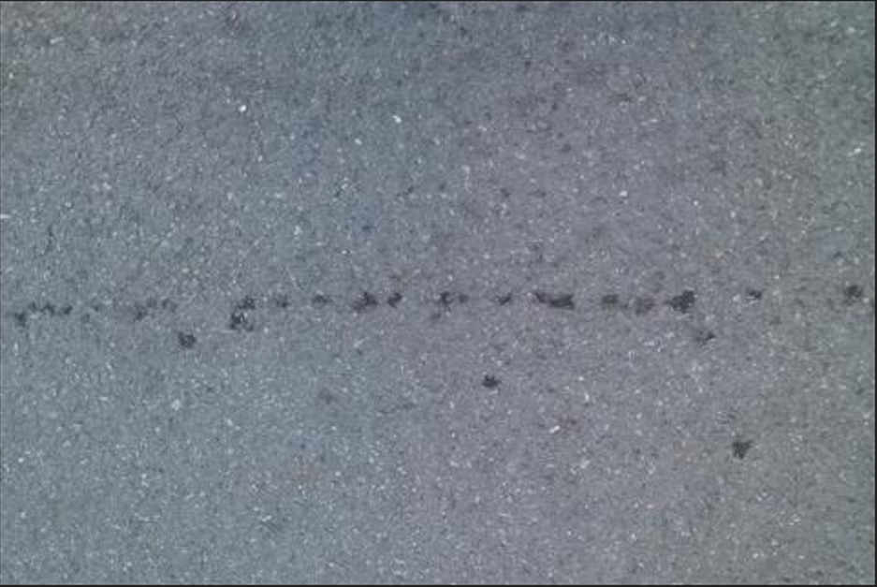
Quick result table generated
Width Formula Verification
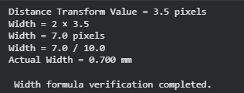
Crack Measurement Points
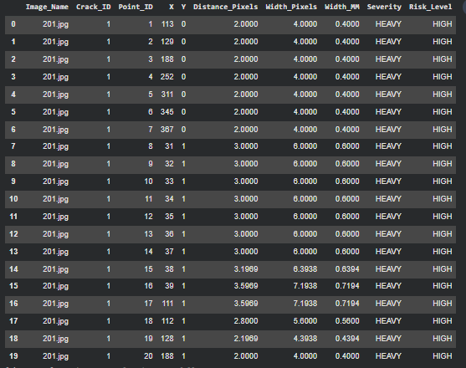

D. Current Project Progress
Overall Project Completion: 95%
Sr. No. | Project Component | Status | Completion
1 | Library Installation | Completed | 100%
2 | Import Libraries | Completed | 100%
3 | Project Configuration | Completed | 100%
4 | Image Upload | Completed | 100%
5 | Image Preprocessing | Completed | 100%
6 | Crack Segmentation | Completed | 100%
7 | Crack Detection | Completed | 100%
8 | Crack Width Estimation | Completed | 100%
9 | Risk Classification | Completed | 100%
10 | Result Visualization | Completed | 100%
11 | CSV Report | Completed | 100%
12 | ZIP Download | Working | 20%

E. Challenges / Issues Faced
- Variations in crack images, such as different lighting conditions, shadows, surface textures, image quality, and crack patterns, affected the consistency of image analysis.
- Selecting suitable OpenCV parameters for Gaussian filtering, black-hat transformation, morphological operations, and crack-area filtering required repeated testing and adjustment.
- Some thin, broken, or low-contrast cracks were difficult to distinguish from background noise and concrete surface patterns.
- Accurate crack-width estimation and pixel-to-mm calibration required proper calibration settings and testing with different crack images.
- During system integration, maintaining consistent results between crack detection, measurement, risk classification, and visualization modules required additional debugging and testing.
- Testing with multiple images revealed variations in detection and measurement results, requiring parameter optimization and result validation.
- The final ZIP Download functionality is still pending and needs to be integrated with the generated annotated images, crack masks, processed images, and CSV report.

F. Actions Taken / Solution Implemented
- Improved crack-image preprocessing using grayscale conversion, Gaussian filtering, black-hat transformation, thresholding, and morphological operations to reduce noise and enhance crack regions.
- Tuned OpenCV parameters such as Gaussian kernel, black-hat kernel, morphological kernel, minimum crack area, and closing iterations to improve detection consistency.
- Implemented crack segmentation and detection to identify crack regions from processed images.
- Implemented skeletonization-based crack analysis for extracting crack structure and supporting length and width measurement.
- Integrated pixel-to-mm calibration with crack-width estimation to obtain measurable crack dimensions.
- Implemented and refined risk classification using defined crack-width/severity thresholds.
- Developed annotated result visualization to display detected crack regions and measurement information clearly.
- Tested the complete analysis workflow with multiple crack images, reviewed outputs, and corrected processing issues found during testing.
- Completed the CSV report generation for storing image-wise crack analysis results.
- ZIP Download functionality remains the only pending feature and will be completed in the next reporting period.

G. Plan for Next Reporting
Sr. No. | Planned Activity | Expected Deliverable | Target Date
1 | Complete ZIP Download functionality | ZIP file containing annotated images, crack masks, processed images, and CSV report | 17 September 2026
2 | Perform final system testing and error handling | Fully tested and stable integrated system | 17 September 2026
3 | Complete final validation, documentation, and project demonstration | Final validated system, complete project report, and demonstration-ready project | 24 September 2026

H. Learning / Skills Acquired
- Technical Skills: Improved practical skills in crack segmentation, detection, width estimation, pixel-to-mm calibration, risk classification, and result visualization.
- Programming Tools: Strengthened skills in Python, OpenCV, NumPy, Pandas, Matplotlib.
- Frameworks: Gained practical experience using OpenCV and Scikit-image for image processing and skeletonization.
- Research Skills: Improved literature review and analysis skills related to computer-vision-based crack detection and structural crack measurement.
- Problem-Solving Skills: Learned to identify and resolve issues related to image noise, thin cracks, parameter selection, segmentation, and measurement accuracy.
- Testing Skills: Gained experience in testing the integrated system with multiple crack images and analysing the generated outputs.
- Documentation Skills: Improved technical documentation, result recording, progress reporting, and project report preparation.
- Teamwork / Communication Skills: Improved communication and presentation skills through project discussions, progress reviews, and explanation of technical development.

4. Tasks Accomplished
- Completed the Risk Classification module based on crack-width measurements and defined severity thresholds.
- Completed Result Visualization with annotated crack images and measurement information.
- Completed CSV Report generation for storing crack analysis results and measurements.
- Integrated the completed modules into the overall crack identification and width estimation workflow.
- Performed testing and validation using multiple crack images and reviewed the generated outputs.
- Improved system performance through parameter tuning, debugging, and error handling.
- Verified the pixel-to-mm calibration and crack-width estimation results.
- Completed the major project components; only ZIP Download functionality remains pending.
5. Tasks in Progress / Next Plan
- Complete the ZIP Download functionality to package all generated project outputs into a single downloadable ZIP file.
- Perform final system testing and error handling after integrating the ZIP download feature.
- Validate the complete workflow from image upload to crack detection, width estimation, risk classification, visualization, CSV report, and ZIP download.
- Finalize project optimization and documentation based on the testing results.
- Prepare the final project demonstration, presentation, and viva.
6. Learnings / Skills Acquired
- Learned to design and organize a complete project workflow from individual modules to final output.
- Improved code integration and modular development skills by connecting multiple project components.
- Gained experience in interpreting project results and identifying areas requiring improvement.
- Learned effective debugging and error-resolution approaches during development and testing.
- Improved understanding of project planning, progress tracking, and milestone management.
- Developed skills in preparing and presenting technical project information clearly and systematically.
References:
- Hassouna, M., Marzouk, M., & Fathalla, E. (2026). Automated Low-Cost Framework for Crack Measurements in RC Structures Using Deep Learning Approach. Scientific Reports, 16, 14678.
- Chen, W., Peng, Z., Chen, X., Zhao, L., Xu, T., Li, Q., Huang, X., & Kannangara, K. K. P. M. (2026). Concrete Crack Detection and Classification Methods Based on Machine Vision and Deep Learning. Sensors, 26(8), 2381.
- Bodke, K., Bhirud, S., & Sangle, K. K. (2026). Enhanced Crack Width and Depth Measurement through Binary Image Processing and Geometric Analysis. Scientific Visualization, 18(1), 49–61.
Evaluation (To be filled by Mentor)
Criteria | Bloom's Level | Excellent (20) | Good (15) | Average (10) | Poor (5) | Marks
Progress as per Previous Plan | L3–Apply | All planned tasks completed | Most completed | Partial completion | Very little progress
Technical / Research Implementation | L4–Analyze | Excellent implementation with clear evidence | Good implementation | Basic implementation | Insufficient evidence
Quality of Deliverables | L5–Evaluate | High-quality, validated deliverables | Good quality | Acceptable | Poor / incomplete
Problem Solving & Challenges | L4–Analyze | Challenges clearly identified and effectively solved | Most issues addressed | Limited solutions | No clear effort
Planning for Next Phase | L6–Create | Clear, realistic and measurable plan | Mostly clear plan | Basic plan | No proper plan
Documentation & Presentation | L3–Apply | Well-structured and professional | Minor issues | Average clarity | Poor documentation
Total marks out of 100

Evaluation
Student Signature | Mentor (Institute)  Signature

Mentor (Institute) Remarks
________________________________________________________________________________________________________________________________________________________________________________________________________________________________________________________________________________________________________________________________________________________________________________________________________________________________________________________________________________________________________________________________________________________________________________________________________________________________________________________________________________________________________________________________________________________________________________________________________________________________________________________________________________________________________________________________________________________________________________________________________________________________________________________________________________________________________________________________________________________________________________________________________________________________________________________________________________________________________________________________________________________________________

